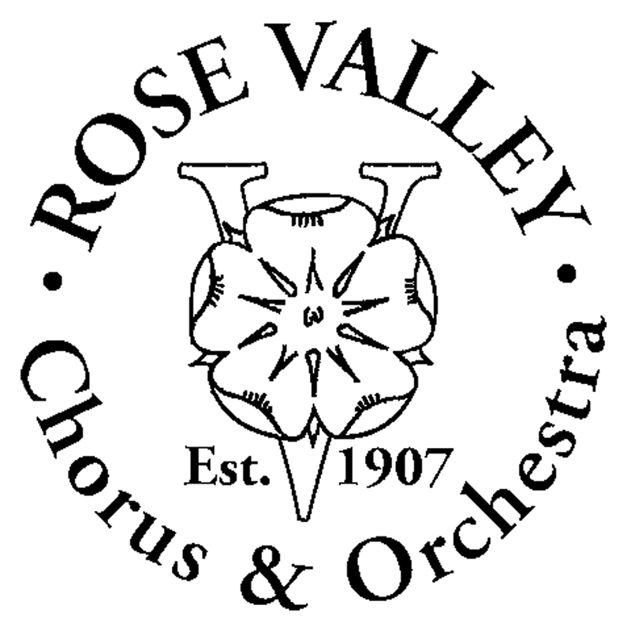

**Rose Valley Chorus & Orchestra  
Box 414 • Media, PA 19063**

**Rose Valley Chorus and Orchestra**

**Audition Announcement**

**Gilbert and Sullivan’s *Gondoliers***

**November 2014**

**Show Information**

|  |  |  |
| --- | --- | --- |
| Directors: | Stage:  Music: | Daniel K. Williams  Carol K. Freed |
| Show Dates: |  | TBD, November 2014 |
|  |  |  |
| Performance Site: |  | Strath Haven Middle School200 South Providence Road, Wallingford, PA 19086-6334 |
| Auditions: | When:  Where: | Sunday, April 27, 2:00 to 4:30 pm  Monday, April 28, 7:00 to 9:00 pm  Stage One Performing Arts Center  (See address below) |
| Auditions are by appointment only | Contact: | Julie Zaffarano  610-325-6568 – phone  [**auditions@rvco.org**](mailto:auditions@rvco.org?subject=RVCO%20auditions%20for%20Gondoliers) – email |
| Rehearsals: | When:  Where: | Sundays 7:00-9:30, Mondays 7:30-10:00, Wednesdays, 7:30-10:00  Stage One Performing Arts Center  101 Plush Mill Rd Summit School, Wallingford, PA 19086  [**www.pacofdelco.org**](http://www.pacofdelco.org) |

**Gondoliers**

**Audition Roles & Selections**

|  |  |  |  |  |
| --- | --- | --- | --- | --- |
| **Role** | **Voice** | **Character Description** | **Music** | **Scene Reading** |
| MEN |  |  |  |  |
| Duke Plaza-Toro | Baritone | A Grandee from Spain | p236-241 | p74-75 |
| Luiz | Baritone/ Tenor | Attendant and royal drummer to the Duke | p82-84, p86-90 | p84-85 |
| Don Alhambra Del Bolero | Baritone/  Bass | The Grand Inquisitor | p91-95 | p90, p95 |
| Marco Palmieri | Tenor | A Venetian Gondolier, brother of Giuseppe | p176-179 | p168, p175 |
| Giuseppe Palmieri | Baritone | A Venetian Gondolier, brother of Marco | p169-175 | p168, p175 |
| Antonio | Baritone | A Venetian Gondolier | p25-29 | p168 (read Giorgio's lines) |
| Francesco | Tenor | A Venetian Gondolier | p21 | p168 (read Annibale's lines) |
| Giorgio | Bass | A Venetian Gondolier | p23 | Dialogue: p168 |
| Annibale | NA | A Venetian Gondolier | (New auditioners will be asked to sing a simple piece) | p168 |
| WOMEN |  |  |  |  |
| Duchess of Plaza-Toro | Contralto | A Grandee of Spain | p232-235 | p231, 235 |
| Casilda | Soprano | Daughter of The Duke and Duchess of Plaza-Toro | p80-84, p88 | p74-75, p84-85 |
| Gianetta | Soprano | Contadine (Italian peasant girl) | p57-59, p119-121 | p213 |
| Tessa | Mezzo | Contadine | p59-61, p113-116 | p194, p213 |
| Fiametta | Soprano | Contadine | p16-18, p21-22 | None |
| Vittoria | Mezzo | Contadine | p24 | None |
| Giulia | Mezzo/Sop | Contadine | p24 | None |
| Inez | Contralto | The King’s Foster-Mother | P264-265 | None |

**About the Show…**

*Gondoliers* is a fun and vibrant show which takes place in the beautiful city of Venice. A young bride of the heir to the throne of Barataria arrives in Venice to join her husband. It turns out, however, that he cannot be identified, since he was entrusted to the care of a drunken gondolier who mixed up the prince with his own son. The two young gondoliers must now jointly rule the kingdom until the nurse of the prince can be brought in to determine which is the rightful king. Moreover, when the young queen arrives to claim her husband, she finds that the two gondoliers have both recently married local girls. A last complicating factor is that she, herself, is in love with another man.

**A little More Info….**

To audition for a role, you must sing and read the specific selections listed above—there will be readers to read with you. The pages listed refer to the Schirmer score. You can also find this material on our web site: www.rvco.org. If time allows, you may audition for up to two roles.

Prior to your audition, you will be sent a copy of our Audition Form by e-mail. You are to complete this form and bring it to your audition.

**Directions to Our Audition Site:**

**Stage One—Performing Arts Complex (PAC) (Summit School)**

101 Plush Mill Road, Wallingford, PA 19086

On Plush Mill Rd., the school is between Providence Rd. (Rte 252) and Turner Rd. **–** closer to Rte 252.

**Coming from the Blue Route:** Take exit 3 and go west on Baltimore Pike towards Media for one mile to Providence Road (Rte 252). Turn left (south) on Rte 252. Plush Mill Road is on the left in 0.8 miles. Turn left on Plush Mill Road and the school is shortly on the left.

**Coming via Providence Road (Rte 252):** Plush Mill Road is 0.8 miles south of Baltimore Pike and

0.5 miles north of the traffic light at Possum Hollow Road and the Wallingford SEPTA RR Station.

**Coming from the West via Route 1 (Baltimore Pike):**  Just past the Granite Run Mall, Route 1 goes off to the right. You go straight ahead on Baltimore Pike for Media. As you go through Media, the 7th traffic light is Route 252—this is a major intersection. Turn right (south) on Rte. 252 (Providence Rd.) 0.8 miles to Plush Mill Rd. on the left. Turn left onto Plush Mill Rd. and the school is shortly on your left.